

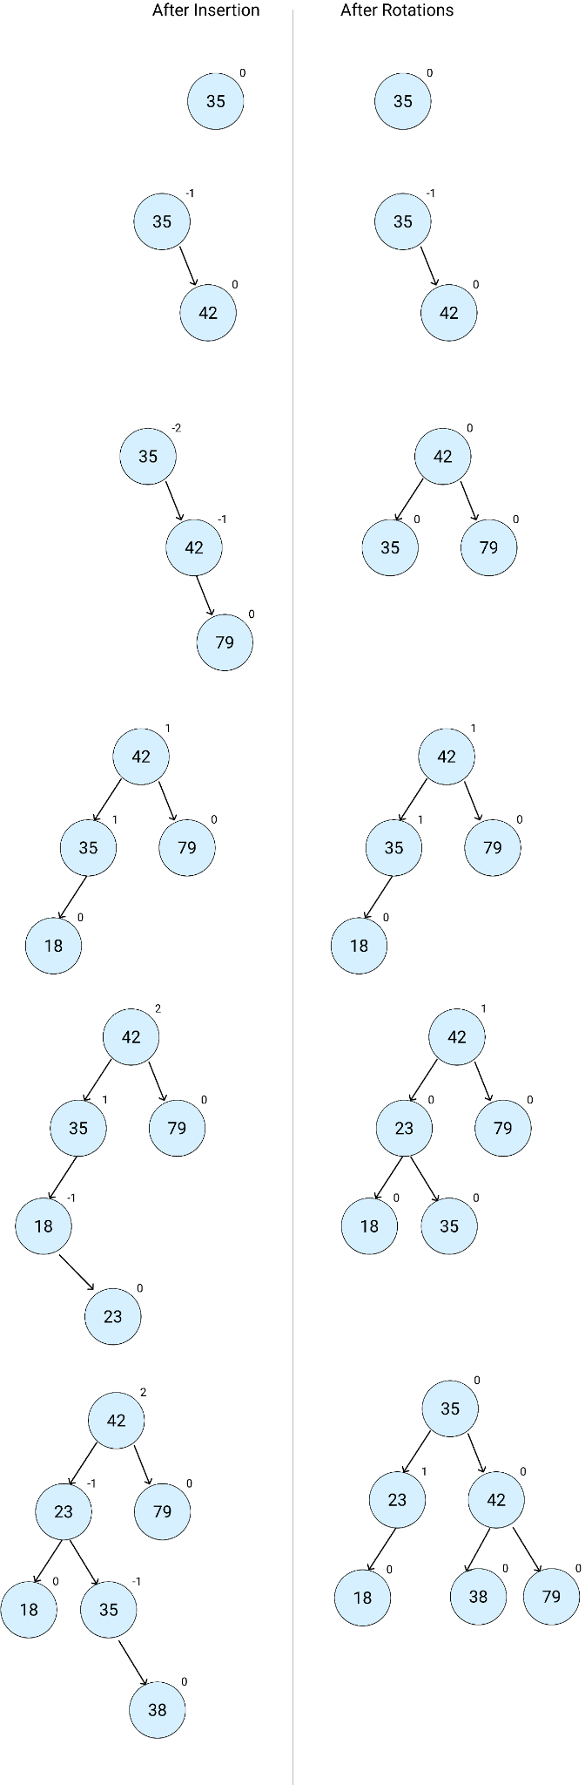



**Question 1.1: Apply the method of heapsort to sort list 23, 35, 42, 79, 18, 38 in ascending order**